DATA VISUALIZATION
AND STORYTELLING
Internship Task 2 – Superstore Sales Analysis

Prepared by: GANESH M
Organization / Internship: ELEVATE LABS
Date: 02-10-2026

1. Introduction
Data visualization is the process of presenting data through charts, graphs, and dashboards to make information easier to understand. It helps reveal patterns, trends, and relationships that may be difficult to identify in raw tables.
This project, Data Visualization and Storytelling, focuses on exploring the Superstore sales dataset using Microsoft Power BI. The dashboard brings together key performance indicators (KPIs), sales trends, regional profit, product category performance, customer segments, and state-level sales.
The objective is to transform sales records into a clear visual report and use the visuals to communicate observations that can support business understanding and data-informed decisions.

2. Objectives
- Data analysis: Examine sales, profit, quantity, orders, product categories, regions, and customer segments.
- Data visualization: Build charts, maps, and KPI cards in Microsoft Power BI.
- Trend identification: Explore how sales vary over time and across business dimensions.
- Business insights: Use the visuals to identify patterns and questions that may require further investigation.
- Data storytelling: Present the findings in an organized dashboard and concise written report.

3. Dataset Description
The project uses the Superstore sales dataset in CSV format. It contains transaction-level information about orders, products, customers, and sales performance.
Key fields used in the analysis:
- Order Date: Date on which an order was placed; used to examine sales over time.
- Sales: Sales amount associated with an order or item.
- Profit: Profit amount associated with an order or item.
- Quantity: Number of units sold.
- Category: Product grouping, including Furniture, Office Supplies, and Technology.
- Region: Geographical region associated with an order.
- Segment: Customer segment associated with an order.
- State: State associated with the order location.

4. Tools and Technologies
- Microsoft Power BI Desktop: Used to import data, create visuals, and assemble the dashboard.
- Superstore CSV dataset: The source data used for the analysis.
- Power Query Editor: Used to inspect and prepare data, including correcting the Order Date data type.
- Microsoft Word: Used to prepare this written project report.

5. Methodology
Step 1: Data collection. The Superstore dataset was obtained in CSV format and imported into Power BI Desktop.
Step 2: Data inspection and cleaning. The data was reviewed in Power Query Editor. The Order Date field required date-type conversion; the conversion was performed using the appropriate locale setting.
Step 3: Field selection. Sales, Profit, Quantity, Order Date, Category, Region, Segment, and State were selected for analysis.
Step 4: KPI creation. Cards were added to summarize total sales, total orders, total profit, and total quantity.
Step 5: Visual development. Charts were created to explore sales by category, sales over time, profit by region, sales by segment, and sales by state.
Step 6: Dashboard arrangement. The visuals were placed on a report canvas and given a dashboard title.
Step 7: Interpretation. The visuals were reviewed to identify patterns. Specific category and regional conclusions should be recorded from the final chart values.

6. Dashboard Components
- KPI cards: Total Sales, Total Orders, Total Profit, and Total Quantity provide a high-level summary.
- Sales by Category: A column chart compares sales across Furniture, Office Supplies, and Technology.
- Sales Trend over Time: A line chart uses Order Date and Sales to show how sales change over time.
- Profit by Region: A bar chart compares profit across the Central, East, South, and West regions.
- Sales by Customer Segment: A donut chart shows how sales are distributed among customer segments.
- Sales by State map: A map visual provides a geographic view of sales by state.
- Sales by State bar chart: A bar chart compares state-level sales values.

7. Initial KPI Summary
The dashboard screenshot shared during the project work displayed the following approximate KPI values. Confirm these values against the saved Power BI report before final submission.
Metric | Displayed value
Total Sales | 2.30M
Total Orders | 5K
Total Profit | 286.40K
Total Quantity | 38K

8. Business Insights and Interpretation
Use the final visuals and their data labels to complete this section. The exact highest category and highest-profit region were not confirmed in the project conversation, so they are intentionally left as fields to fill from the report rather than assumed.
Category performance: Highest-sales category: Technology . Compare the sales values for Furniture, Office Supplies, and Technology. Note any category with comparatively lower sales.
Regional profitability: Highest-profit region: West . Compare profit across Central, East, South, and West. Note whether any region has low or negative profit.
Sales over time: Describe the main pattern visible in the monthly sales trend. Mention any visible peaks, declines, or recurring patterns.
Customer segments: Identify the segment with the largest share of sales from the donut chart. Record the segment shares if available.
State-level sales: Record the states with the highest and lowest sales shown in the map or bar chart. Confirm that the map locations are correctly categorized.

9. Dashboard Screenshots
Insert screenshots of the completed Power BI report in this section. Recommended evidence:
- Full dashboard view showing the title, KPI cards, and all charts.
- A closer view of Sales by Category and the sales trend chart.
- A closer view of Profit by Region, Sales by Segment, and the state-level visualizations.
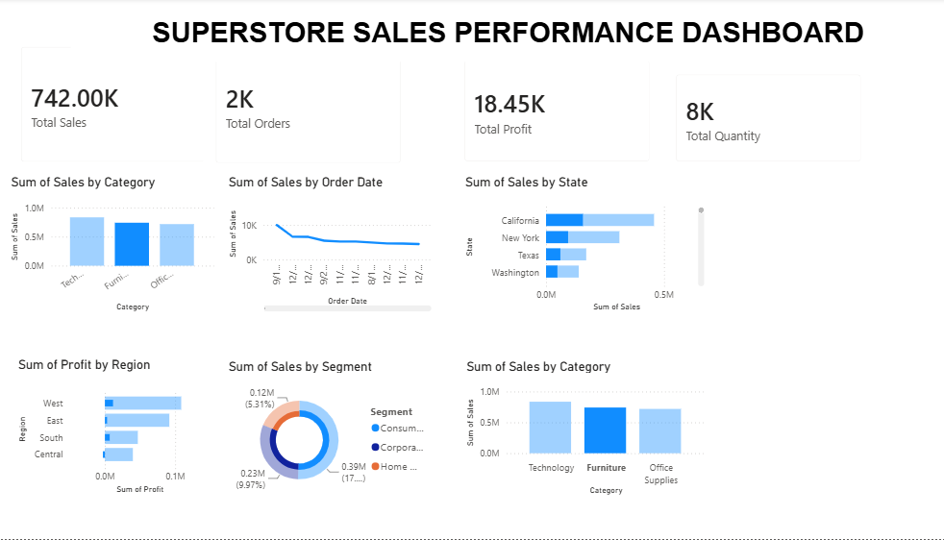

10. Conclusion
This project demonstrates a basic end-to-end data visualization workflow using the Superstore dataset and Microsoft Power BI. The data was imported and prepared, KPI cards and multiple chart types were created, and the visuals were organized into a single dashboard.
The dashboard provides a visual overview of sales, profit, order volume, product categories, customer segments, time-based trends, and geographic performance. The final business conclusions should be based on the exact values and patterns visible in the saved report. This helps ensure that the written story is accurate and supported by the data.

11. Limitations and Future Improvements
- Verify all displayed KPI values and chart aggregations against the source dataset before submission.
- Add slicers for date, category, region, and segment to make the report more interactive.
- Use tooltips and data labels where they improve readability without overcrowding the visuals.
- Check geographic data categories and map settings to ensure state locations are plotted correctly.
- Add a dedicated page with confirmed findings, supporting values, and practical recommendations.
- Capture final screenshots and include the Power BI .pbix file and dataset in the project repository, subject to dataset licensing and internship submission rules.

12. Submission Checklist
☐ Power BI report saved as a .pbix file.
☐ Dashboard title and visuals checked for readability and overlap.
☐ KPI values checked against the report.
☐ Business insights completed using actual chart results.
☐ Screenshots inserted into this report.
☐ Report exported to PDF if required.
☐ Dataset, project file, screenshots, and README organized in the GitHub repository as required by the task.

